
Congratulations!!!


FROM: THE DESK OF THE UK NATIONAL LOTTERY E-MAIL PROMOTIONS MANAGER INTERNATIONAL
PROMOTIONS/PRIZE AWARD DEPARTMENT, UK NATIONAL LOTTERY CORPORATION SWEEPSTAKES WORLD LOTTERY W1U 1PJ P.O.BOX 1010 LONDON, UNITED KINGDOM.

REFERENCE NO: UK/9876125
BATCH NO: 2011MJL-01
TICKET No: 20511465463-7644
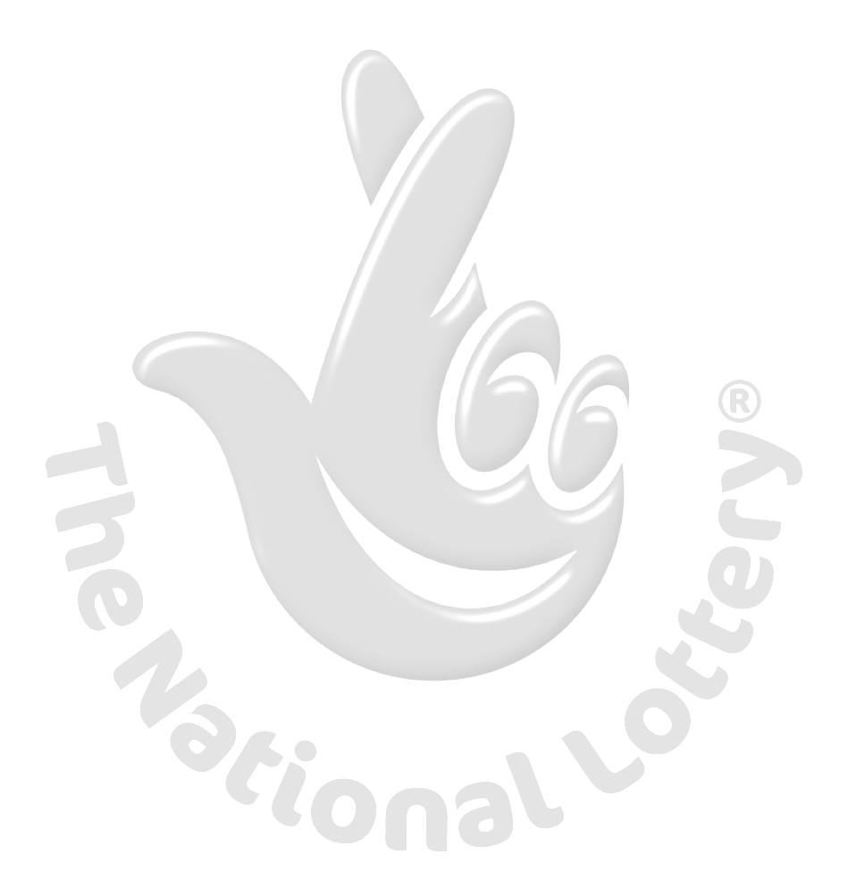
ELECTRONIC EMAIL AWARD WINNING NOTIFICATION AWARD PRESENTATION CENTER: UNITED KINGDOM

DEAR WINNER,

UK NATIONAL LOTTERY WORLDWIDE ARE PLEASED TO INFORM YOU THAT THE FINAL ANNOUNCEMENT THAT YOU ARE ONE OF OUR LUCKY WINNERS OF THE UKNL UNITED KINGDOM INTERNATIONAL LOTTERY PROGRAM HELD ON THE 15TH JULY, 2011.THE ONLINE UK LOTTO DRAWS WAS CONDUCTED FROM AN EXCLUSIVE LIST OF 147,000 E-MAIL ADDRESSES OF INDIVIDUALS AND CORPORATE BODIES PICKED BY AN ADVANCED AUTOMATED RANDOM COMPUTER SEARCH FROM THE INTERNET WITHOUT ANY PHISICAL TICKETS SOLD.

AFTER THIS AUTOMATED COMPUTER BALLOT, YOUR E-MAIL ADDRESS EMERGED AS ONE OF THREE WINNERS IN THE CATEGORY "A" WITH BATCH No: 2011MJL-01 AND WITH THE FOLLOWING WINNING INFORMATION: YOU ARE HENCEFORTH APPROVED TO CLAIM A TOTAL SUM OF £315,000.00 (THREE HUNDRED AND FIFTEEN THOUSAND POUNDS STERLING). PAYABLE IN CASH CREDITED TO FILE REF NO: UK/9876125. THIS IS FROM TOTAL PRIZE MONEY OF £ 27,500,000.00 POUNDS STERLING, SHARED AMONG THE 50 LUCKY INTERNATIONAL WINNERS.

ALL PARTICIPANTS WERE SELECTED THROUGH OUR MICROSOFT COMPUTER BALLOT SYSTEM DRAWN FROM 147,000 EMAILS, 21,000 EMAILS FROM EACH CONTINENT (AFRICA, ANTARCTICA, ASIA, AUSTRALIA, EUROPE, NORTH AMERICA, AND SOUTH AMERICA.

YOUR FUND (CERTIFIED CHEQUE AND YOUR WINNING CERTIFICATE) HAS BEEN INSURED WITH YOUR REF NO: UK/9876125 AND WILL BE READY FOR TRANSFER. PLEASE NOTE THAT, YOU ARE TO
CONTACT YOUR CLAIMS OFFICER VIA EMAIL OR TELEPHONE AS WE ARE PROMOTING THE USE OF E-MAIL.

IN ADDITION, YOU HAVE THE RIGHT TO CALL HIM TO CONFIRM YOUR WINNINGS AND GOVERNMENT TAX PAYMENT THAT IS ALL, AS HE WILL PROVIDE YOU WITH THE NECESSARY DETAILS ON HOW TO CLAIM YOUR PRIZE. AS PART OF OUR SECURITY PROTOCOL, YOU ARE TO QUOTE THIS SECURITY CODE MSW/MAY/XX07 TO YOUR CLAIMING AGENT. THIS IS TO PREVENT ANY FRAUDULENT ACTS.

CONTACT YOUR CLAIMS AGENT OFFICER IN UNITED KINGDOM.
NAME: MR. IAN WALTER
EMAIL: winerfundsclaims@live.co.uk
TELEPHONE: +44 704 578 7764

NOTE: BE WARNED NOT TO REPLY MAILS LIKE THIS ON NET, AS THERE ARE A LOTS OF SCAM ARTIST OUT THERE PRETENDING TO BE US. YOUR CLAIM AGENT, MR IAN WALTER IN UNITED KINGDOM WILL ASSIST YOU IN THE PROCESSING OF YOUR PRICE REDEEMTION WITH YOUR CHOSEN PAYMENT CENTRE.

CONGRATULATIONS, ONCE MORE FROM THE ENTIRE MANAGEMENT AND STAFF OF UKNL BOARD CO-OPERATION TO ALL OUR LUCKY WINNERS. THANK YOU FOR BEING PART OF THIS PROMOTIONAL LOTTERY PROGRAM. OUR SPECIAL THANKS AND GRATITUDE TO ALL THE ASSOCIATES FOR ALLEVIATING POVERTY ROUND THE WORLD.

SINCERELY.
MRS Elayne Lima (PE)
ONLINE CO-ORDINATOR









MRS Elayne Lima
(ONLINE CO-ORDINATOR)

LOTTERY SPONSORS: CHIEF SPONSORS;
UKNL CORPORATION UK, UKNL CORPORATION AFRICA,
UKNL CORPORATION USA, UKNL CORPORATION ASIA.

Past winners.
REF: SETTLEMENT CENTRE:
IT IS MY PLEASURE TO INFORM YOU THAT WE HAVE ONE SETTLEMENT CENTERS WHERE YOU WILL CONTACT FOR REDEEMING OF YOUR WINNING PRIZE OF £315,000.00 (THREE HUNDRED AND FIFTEEN THOUSAND POUNDS STERLING).

NAME: SCARLET COURIER COMPANYSCARLET COURIER COMPANY TRUSTED TESTED WHO CAN DELIVER YOUR WINNING TO YOU IN ANY PART OF THE WORLD.
FOR YOUR PRICE TO BE PROCESSED YOU NEED TO CONTACT YOUR CLAIMS AGENT: MR IAN WALTER. FILL UP THIS FORM AND SEND IT TO (winerfundsclaims@live.co.uk).YOU ALSO HAVE TO SEND SCANNED COPY OF YOUR VALID INTERNATIONAL DRIVER`S LICENCE OR PASSPORT TO AVOID DOUBLE CLAIM.

ONCE WE RECEIVE THE REQUIRED INFORMATIONS, THEY WILL BE FORWARDED TO YOUR CHOSEN DELIVERY PAYMENT CENTRE ALONGSIDE YOUR ORIGINAL WINNING CERTIFICATE
ALL YOU NEED TO DO IS TO GIVE THEM YOUR ADDRESS INFORMATION WHERE YOU WANT THE CHEQUE TO BE DELIVERED TO.

YOU’RE WINNER: NO 04
NAME | :
ADDRESS | :
NATIONALITY | :
GENDER | :
AGE | :
PHONE | :
OCCUPATION | :
COMPANY | :
SECURITY CODE | :
TICKET NO | :
PAYMENT CENTER | :
NOTE THAT THERE EXISTS A PERIODIC CONDITION ON ALL CLAIMS PROCESS; THEREFORE, YOU HAVE LIMITED TIME TO CLAIM YOUR WINNINGS. FAILURE TO CLAIM YOUR WINNINGS WITHIN THE STIPULATED TIME FRAME WILL LEAD TO THE FORFEITURE OF YOUR WINNINGS AFTER WHICH YOUR WINNINGS REMITTED BACK TO THE UKNL BOARD HEADQUARTERS AND WILL THEN BE ADDED TO NEXT WINNING DRAWS. ALSO KINDLY BE AWARE THAT THE FINANCIAL SERVICES AUTHORITY REGULATES THE UKNL BOARD LOTTERY WINNING PRIZES AND AS A RESULT, YOU ARE ADVICE TO FOLLOW THE LOTTERY CLAIMS TERMS AND CONDITIONS TO ENSURE THE REMITTANCE OF YOUR PRIZE TO YOU WITHIN THE STIPULATED TIME OF THE CLAIMING OF WINNINGS.

