

Yahoo Awards Center

Yahoo Awards Center

124 Stockport Road, Longsighted, Manchester M60 2DB - United Kingdom

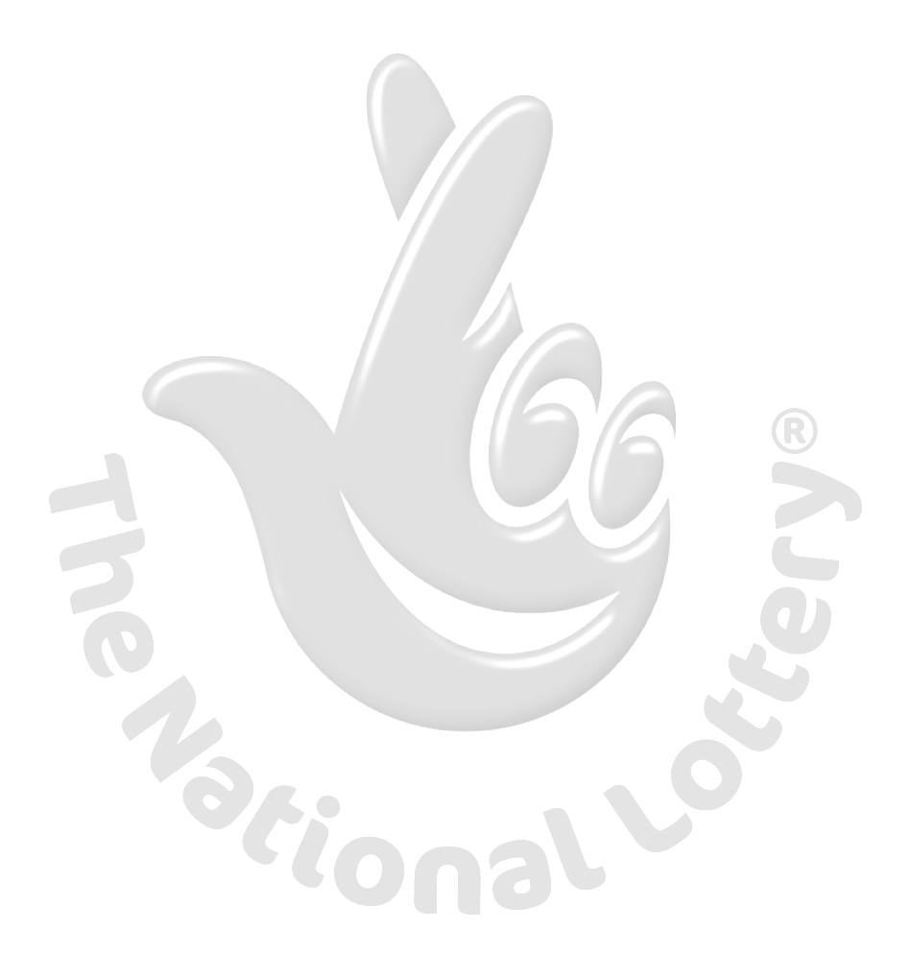
This is to inform you that you have won a prize money of One Million British Pounds (£1,000,000.00) for 2011 Prize promotion which is organized by YAHOO, AOL & WINDOWS LIVE every (2) yrs. YAHOO and MICRO SOFT collects all the email addresses of the people that are active online, among the millions that subscribed to Yahoo and Hotmail and few from other e-mail providers. Five people are selected every two years to benefit from this promotion and you are one of the Selected Winners.
PAYMENT OF PRIZE AND CLAIM.
Winners shall be paid in accordance with his/her Settlement Center. Yahoo Prize Award must be claimed no later than 29th days, from date of Draw Notification. Any prize not claimed within this period will be forfeited. Stated below are your identification numbers: BATCH NUMBER: MFI/08/APA-43658, REFERENCE NUMBER: MSW-L/200-26937/ PIN: 1208 WINNING NUMBER: 01 14 21 30 35 48 These numbers fall within the Johannesburg Location file, you are requested to contact our fiduciary agent in Johannesburg South Africa and send your winning identification numbers to him:

NAME: Mr.Goodluck Favour James Cross
E-MAIL: award.center@blumail.org
TEL: + 00 27 78 228 7025
You are advised to send the following information to your Claims Agent to facilitate the release of your fund to you.

1. Full name.................................................
2. Country................................………………..
3. Contact Address...................………………..
4. Telephone Number...............……………….
5. Fax Number.... ......................………………
6. Marital Status.......................……………….
7. Occupation...........................……………….
8. Date of birth...................……………………
9. Gender...............................…………………
10.Mode of payment: {Bank Transfer or coming for your claim}

To file for your claim, Please contact your Validating Officer for VALIDATION of your winning within Twenty-nine working days of this winning notification. Winnings that are not validated within Twenty-nine working days of winning notification are termed void and invalid. You are required to mention the above particulars of your award in every correspondence to enable the Agent in South Africa validate your winning.

Congratulations!! Once again. WINNER NO: 5

