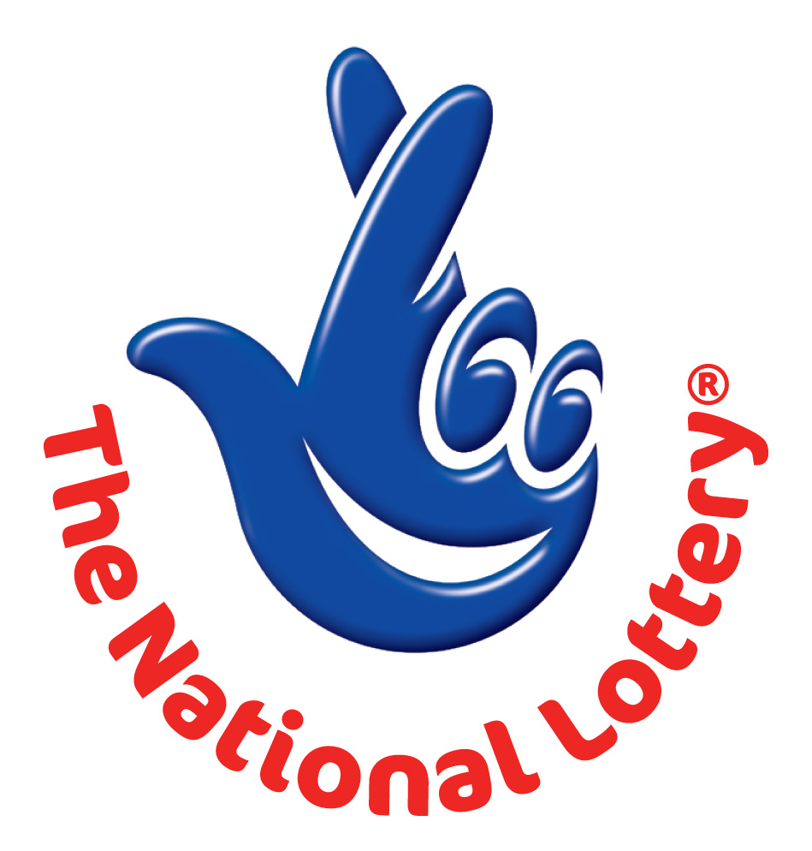
CANADA LOTTERY/ EMAIL DRAW ONTARIO 49
1550 Princess Street Kingston, ON, Canada, K7M 9E3
Web; http://6 /on490309.html
UK Office No 47 Se1 7na – Balking London United Kingdom
24hrs.Tell; +44 703 174 2888
Email:bright.rossman.999@gmail.com

WINNING NUNBERS
13 | 17 | 23 | 27 | 35 | 37 | Bonus 34
Attn: Winner,

We happily announce to you the draw of Canadian National Lottery the UK/CANADA online Sweepstakes International program held this year 2011.

You have won GBP 1,000,000.00 (One Million British pounds Only) from Canadian lottery draw 2011.Your Email ID was one of the selected email all over the world in the lottery draw and it comes out one of the lucky winning number.

For us to process your winning for transfer you are advice to contact our judiciary agent with the details below in London for your payment.

Name: BRIGHT ROSSMAN
Email: bright.rossman.999@gmail.com
Email: bright.rossman.999@gmail.com

Telephone: +44 703 174 2888

Please forward to him the following details below

1. Name (in Full):
2. Country:
3. Address:
4. Direct Telephone No:
5. Age:
6. Occupation/position:

Congratulations!! Once again.

Yours in service,
Dr. (Mr.) Paul Smith.
[Publicity Secretary]

